7/16 DIN Male Crimp Connector For LMR400 Cable

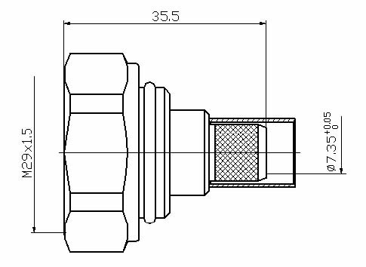

Interface
According to IEC 60169-4

Electrical
Characteristic Impedance 50 ohm
Frequency Range DC-7.5GHz
VSWR ≤1.20@DC-3000MHz
Dielectric Withstanding Voltage ≥4000V RMS,50Hz,at sea level
Dielectric Resistance ≥10000MΩ
Contact Resistance Center Contact ≤0.4mΩ
Outer Contact ≤1 mΩ
Mechanical
Durability Mating cycles ≥500
Material and plating
Material Plating
Body Brass Ni
Insulator PTFE －
Center conductor Phosphor bronze Ag
Coupling Nut Brass Ni
Crimping tube Annealed Copper Ni
Gasket Silicone Rubber －

Environmental
Temperature Range -40℃～+85℃
Weatherproof Rate IP 68
RoHs Compliant

