7/16 DIN Female SQ Flange Mount Connector For RG402(141”))

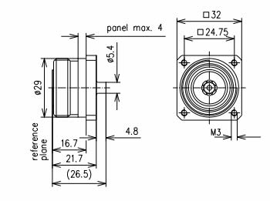

Interface
According to IEC 60169-4

Electrical
Characteristic Impedance 50 ohm
Frequency Range DC-7.5GHz
VSWR ≤1.10@DC-4000MHz
Dielectric Withstanding Voltage ≥4000V RMS,50Hz,at sea level
Dielectric Resistance ≥10000MΩ
Contact Resistance Center Contact ≤0.4mΩ
Outer Contact ≤1 mΩ
Intermodulation 3rd (PIM3) ≤ -165dBc@2×20W

Mechanical
Durability Mating cycles ≥500

Material and plating
Material Plating
Body Brass Tri-Metal
Insulator PTFE(Teflon) －
Center conductor Phosphor Copper Ag(Silver)
Gasket Silicone Rubber －

Environmental
Temperature Range -40℃～+85℃
Weatherproof Rate IP 68
Operating Power ≥500Watt
RoHs (2002/95/EC) Compliant

