3-1/8″EIA Flange Connector For 3-1/8″Air Dielectric Coaxial Cable

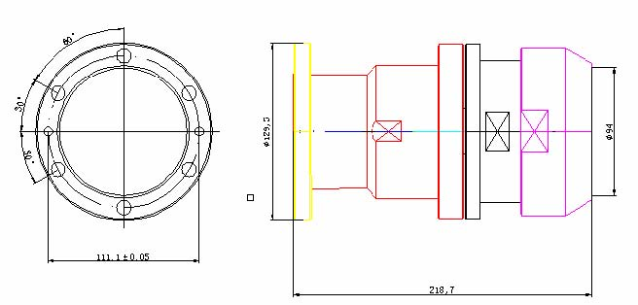
Interface
According to 3-1/8″ EIA Flange

Electrical
Characteristic Impedance 50 ohm
Operating Frequency Range DC-3GHz
VSWR ≤1.07@DC-1000MHz
Dielectric Withstanding Voltage ≥6000V RMS,50Hz,at sea level
Dielectric Resistance ≥5000MΩ
Average Power 23KW@900MHz
Peak Power Maximum 120KW
Contact Resistance Center Contact ≤1.5mΩ
Outer Contact ≤1.5mΩ
Mechanical
Durability Mating cycles ≥500
Material and plating
Material Plating
Body Brass Ni
Insulator PTFE －
Center conductor Phosphor bronze Ag
Coupling Nut Brass Ni
Other Parts Brass Ni
Gasket Silicone Rubber －
Bolts and Washer Stainless Steel －

Environmental
Operating Temperature Range -45℃～+85℃
Weatherproof Rate IP 67
RoHs Compliant

