1000mm 1/4” Superflexible Cable Jumper
( N Male to N Male Connector )

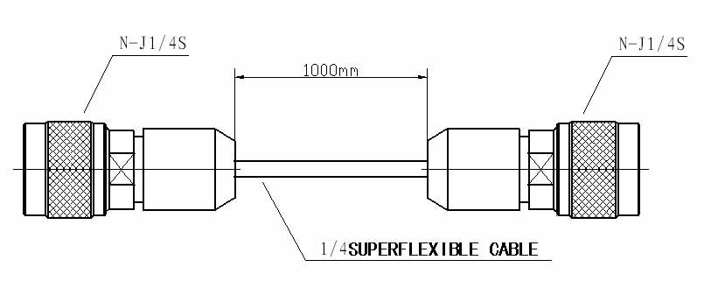
Connector Interface: CECC 22190 ;IEC 60169-4 ;DIN 47223

Electrical
Characteristic Impedance 50 ohm
Frequency Range DC-3 GHz
VSWR ≤1.10@698-960MHz
≤1.10@1900-2500MHz
Dielectric Withstanding Voltage ≥2500V RMS,50Hz,at sea level
Dielectric Resistance ≥5000MΩ

Mechanical
Durability Mating cycles ≥500

Material and Plating
Material Plating
Body Brass Ni
Insulator PTFE －
Center conductor Phosphor bronze Au
Coupling nut Brass Ni
Gasket Silicone Rubber －
Shrinkable Tube PVC －

Cable Family 1/4” Superflexible cable (Made by China Cable manufacturer)

Environmental
Temperature Range -40℃～+85℃al
Weatherproof Rate IP 67
RoHs 2002/95/EC Compliant

1/4″Super Flexible Cable

Construction Specification
 | Material | Diameter(mm)
1. Inner Conductor | Copper Clad Aluminum Wire or Copper | 1.90
2. Dielectric | Physical Foam Polyethylene | 4.70
3. Outer Conductor | Helical Copper Tube | 6.35
4. Jacket | Black PE or  Low Smoke Halogen-free Fire-retardant PE | 7.50

Electrical Characteristics Mechanical and Environmental Characteristics
Capacitance(pF/m) |  |  |  | 80 |  |  |  |  |  | Min. Single Bending Radius(mm) |  |  | 12.50
Impedance(ohm) |  |  |  | 50 |  |  |  |  |  | Min. Repeated Bending Radius(mm) |  |  | 25
Velocity(%) | 83 |  |  |  | No. of Bends |  |  | 15
Peak Power Rating(KW) | 6.40 |  |  |  | Mobile Apply(mm) |  |  | 350
RF Peak Voltage(KV) | 0.80 |  |  |  | Bending Moment(N.m) |  |  | 5.0
Insulation Resistance(MΩ.km) | >5000 |  |  |  | Tensile Strength(kg) |  |  | 60
Cut-off Frequency(GHz) | 20.4 |  |  |  | Storage Temp.(℃) |  |  | -55to+85
Insulation Voltage(KV) | 2.0 |  |  |  | Installation Temp. (℃) |  |  | -40to+60
Inner Conductor DC Resistance(Ω/km) | 9.50 |  |  |  | Operating Temp.( ℃) |  |  | -55to+85
Outer Conductor DC Resistance(Ω/km) |  |  |  | 5.70
Jacket Spark(KV) |  |  |  | 3.0
Shielding Effectiveness(dB) | >120
VSWR≤(Return loss≥dB)
0.005-3GHz |  | 1.15 |  | (23)
0.8-1.0GHz | 1.10 |  | (26)
1.7-2.0GHz | 1.10 |  | (26)
2.0-2.4GHz | 1.10 |  | (26)

Attenuation(VSWR1.0,cable temp.20℃) and Average Power(VSWR1.0,ambient temp.40℃)
Frequency(MHz) |  | Attenuation(≯dB/100m) |  | Average Power(KW)
100 |  | 5.60 |  | 1.23
200 | 8.00 |  | 0.86
450 | 12.20 |  | 0.57
800 | 16.70 |  | 0.42
900 | 17.50 |  | 0.39
1000 | 18.60 |  | 0.37
1500 | 23.40 |  | 0.30
1800 | 25.70 |  | 0.27
2000 | 26.90 |  | 0.26
2200 | 28.50 |  | 0.25
2400 | 30.00 |  | 0.24
2500 | 30.60 |  | 0.23
3000 | 33.50 |  | 0.21

