1/4 Wavelength Type Surge Arresotor
7/16 DIN Male and 7/16 DIN Female
Dimension :
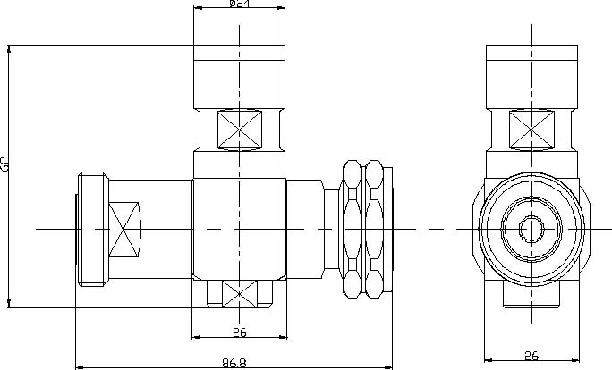
Number | Designation | Material | Electroplating
1 | Swivel nut | Brass rods | Tri-Metal
2 | Hull | Brass rods | Tri-Metal
3 | Plughole | Bronze Bar | Ag
4 | Contact pin | Brass rods | Ag
5 | Inner conductor | Brass rods | Ag
6 | Sealing element | Silicon rubber | -
7 | Dielectric | PTFE | -
8 | SC | Stainless | -

Test item |  |  | Standard Parameter
Withstand voltage(V) |  |  | 4000V 1min No breakdown and no  arcing phenomenon
Insulation Resistance(MΩ) |  |  | ≥1x104
Contact resistance(MΩ) | Inner conductor |  | ≤0.4
Contact resistance(MΩ) |  | Outer conductor | ≤0.2
Impedance（Ω） |  |  | 50
Frequency Range (MHz) |  |  | 700-2500
Max. Peak Power(W) |  |  | 3000
Discharging current(kA@8/20μS) |  |  | 30
Residual Voltage(1kV/μs) |  |  | ＜30
Insertion Loss（dB） |  |  | ≤0.15
V.S.W.R. |  |  | ≤1.18
Water-proof |  |  | IP67

