Discharge Tube Type Surge Arrester
N Male to N Female

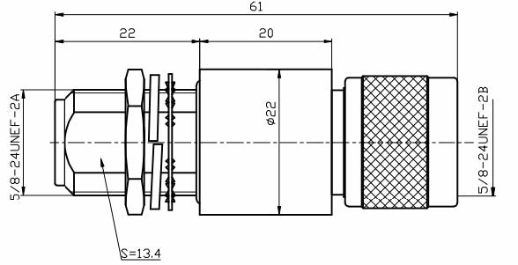
Interface According to IEC 60169-16
Electrical
Characteristic Impedance 50 ohm
Dielectric Resistance ≥5000 M ohm
Contact Resistance Center Contact ≤1mΩ
Outer Contact ≤1mΩ
AC Withstand Voltage 2500V / 1 Min No breakdown and No Arcing Phenomenon
Frequency Range DC-6GHz
VSWR ≤1.15@DC-6GHz
Insertion Loss ≤0.15dB
Initial Discharge Voltage 75/90/150/230/350V
Average RF Power 30W-400W(Depending on gas tube)
Peak RF Power ＜600W
Maximum Discharge Current 20KA(8/20μs)

Material and Plating
Parts Name Material Plating
Housing(Body) Brass Ni
Insulator PTFE －
Center Pin Phosphor Bronze Au
Inner Conductor Phosphor Bronze Au
O-ring (Sealing) Silicon Rubber －
Standard Component Stainless Steel －

Environmental
Temperature Range -45℃～+85℃
Weatherproof Rate IP 67
RoHs Compliant

