2 W SMA Coaxial Attenuator

Drawing and Dimension:

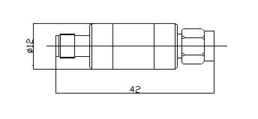

Operating Freq. | DC –3GHz
Average Power | 2W
Peak Power | 5µs：0.5KW
Attenuation value | 3dB | 5dB | 6dB | 10dB | 15dB | 20dB | 30dB
Accuracy | ±0.4dB | ±0.5dB | ±0.5dB | ±0.7dB | ±0.7dB | ±0.8dB | ±0.8dB
VSWR | ≤1.15
Connector | SMA- Male / Female
Housing | AL rod (Passivation)
Connector Body | Brass Rod (Nickel plating)
Inner conductor | Phosphor Bronze (Gold plating)
Gasket Parts | Silicone Rubber
Impedance | 50Ω
Operating Temp. | -40～+85℃
Net Weight | 15g

