10 W SMA Type Coaxial Attenuator

Drawing and Dimension:
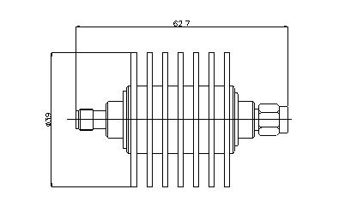

Operating Freq. | DC –3GHz
Average Power | 10W
Peak Power | 5µs：0.5KW
Attenuation value | 3dB
Accuracy | ±0.4dB | 5dB | 6dB | 10dB | 15dB | 20dB | 30dB
VSWR | ≤1.15 | ±0.5dB | ±0.5dB | ±0.7dB | ±0.7dB | ±0.8dB | ±0.9dB
Connector | SMA- Male / Female
Impedance | 50Ω
Operating Temp. | -40～+80℃
Weight | 100g

