20 W SMA Type Coaxial Attenuator

Drawing and Dimension:
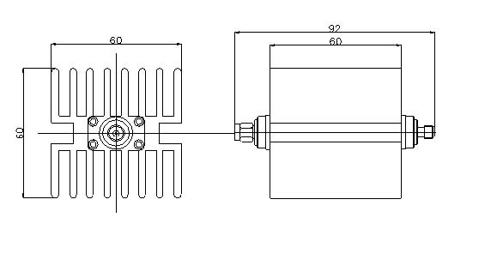

Operating Freq. | DC –3GHz
Average Power | 20W
Peak Power | 5µs：0.5KW
Attenuation value | 3dB | 5dB | 6dB | 10dB | 15dB | 20dB | 30dB
Accuracy | ±0.4dB | ±0.5dB | ±0.5dB | ±0.7dB | ±0.7dB | ±0.8dB | ±0.8dB
VSWR | ≤1.15
Housing | Aluminum(Black Plating )
Connector body | Brass (Nickel Plating )
Gasket Parts | Silicone Rubber
Connector | SMA- Male / Female
Inner conductor | Phosphor Bronze (Gold plating)
Impedance | 50Ω
Operating Temp. | -40～+80℃
Coating | Black plated(Housing)
Weight | 300g

