100W N type Coaxial Dummy Load ( Terminator)

Drawing and Dimension:
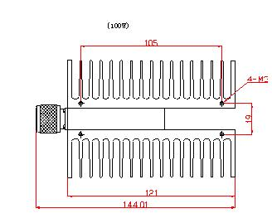
Freq. Range | DC-3GHz
Power capacity | 100W
VSWR | ≤1.2
Impedance | 50Ω
Connector | N- Male
Housing | Aluminum
Operating Temp. | -40～+85℃
Waterproof rate | IP67
Storage Temp. | -60～+100℃
Weight | 1100g

