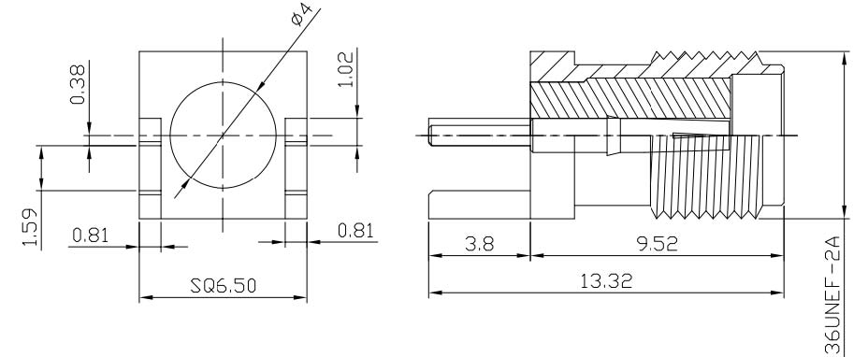
SMA Female Straight Connector Edge Mount Without Nut
Interface
According to |  |  | IEC 60169-15
Electrical
Characteristic Impedance |  |  | 50 ohm
Typical Frequency Range |  |  | DC-6GHz
VSWR |  |  | ≤1.10@DC-3GHz
Dielectric Withstanding Voltage |  |  | ≥1000V RMS,50Hz,at sea level
Dielectric Resistance |  |  | ≥5000MΩ
Contact Resistance |  |  | Center Contact ≤3mΩ
 |  |  | Outer Contact ≤2.5mΩ
Mechanical
Durability |  |  | Mating Cycles ≥500
Material and Plating
 |  | Material | Plating
Body |  | Brass | Au(Gold)
Insulator |  | PTFE(Teflon) | －
Center conductor |  | Phosphor Copper | Au(Gold)
Environmental
Operating Temperature Range |  |  | -40℃～+85℃
RoHs | Compliant

Tel:0086-511-88896930;Fax:0086-511-88892399;Email:herryma71@hotmail.com;www.fscommunication.com

