SMA Male Crimp Connector For LMR200 Cable
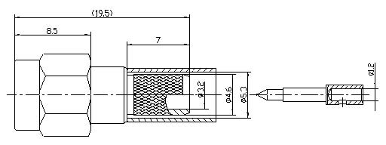
Interface
According to |  | IEC 60169-15
Electrical
Characteristic Impedance |  | 50 ohm
Typical Frequency Range |  | DC-6GHz
VSWR |  | ≤1.15@DC-3GHz
Dielectric Withstanding Voltage |  | ≥1000V RMS,50Hz,at sea level
Dielectric Resistance |  | ≥5000MΩ
Contact Resistance |  | Center Contact ≤3mΩ
 |  | Outer Contact ≤2.5mΩ
Mechanical
Durability |  | Mating Cycles ≥500
Material and Plating
 | Material | Plating
Body | Brass | Au
Insulator | PTFE(Teflon) | －
Center conductor | Phosphor Copper | Au
Coupling Nut | Brass | Au
Ferrule | Annealed Copper | Ni
Gasket | Silicone Rubber | －
Environmental
Operating Temperature Range |  | -40℃～+85℃
RoHs Compliant

