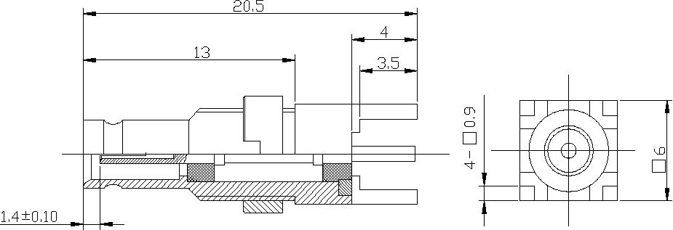
1.0/2.3 Female Straight Bulkhead Connector For P.C.B
Interface
According to | IEC 61169-29;CECC 22230;DIN47297
Electrical
Characteristic Impedance | 50 ohm
Frequency Range | DC-4GHz
VSWR | ≤1.25@DC-2GHz
Dielectric Withstanding Voltage | ≥750 V R.M.S,At sea level
Dielectric Resistance | ≥1000MΩ
Contact Resistance | Center Contact ≤4mΩ
 | Outer Contact ≤2.5mΩ
Mechanical
Durability | Mating cycles ≥500
Material and plating
 | Material | Plating
Body
Insulator | PTFE |  | －
Center conductor | Phosphor bronze |  | Au
Resilient Contact | Phosphor bronze |  | Au
Coupling Nut | Brass |  | Ni
Environmental
Temperature Range | -40℃～+85℃
RoHs Compliant

