1.0/2.3 Male Crimp Connector For BT3002 Cable
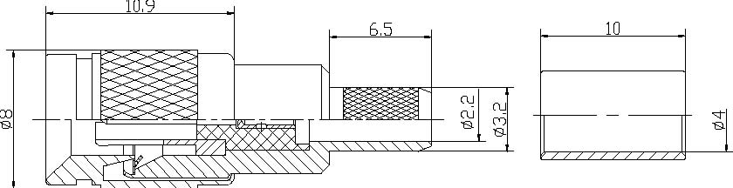
Interface
According to | IEC 61169-29;CECC 22230;DIN47297
Electrical
Characteristic Impedance | 50ohm
Frequency Range | DC-4GHz
VSWR | ≤1.25@DC-1GHz
Dielectric Withstanding Voltage | ≥750 V R.M.S,At sea level
Dielectric Resistance | ≥1000MΩ
Contact Resistance | Center Contact ≤4mΩ
 | Outer Contact ≤2.5mΩ
Mechanical
Durability | Mating cycles ≥500
Material and plating
 | Material | Plating
Body | Brass | Ni
Insulator | PTFE | －
Center conductor | Phosphor bronze | Au
Resilient Contact | Phosphor bronze | Au
Ferrule | Annealed Copper | Ni
Gasket(O-ring) | Silicone Rubber | －
Environmental
Temperature Range | -40℃～+85℃
RoHs Compliant

