FME Male Crimp Connector For RG58 Cable

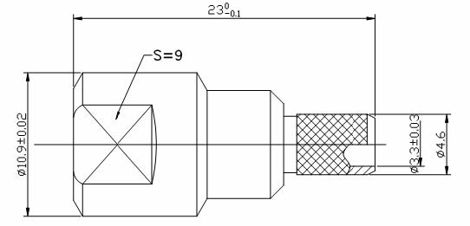
Electrical
Characteristic Impedance 50 ohm
Typical Frequency Range DC-3GHz
VSWR ≤1.25@DC-3GHz
Dielectric Withstanding Voltage ≥1000V RMS,50Hz,at sea level
Working Voltage 500V RMS,50Hz,at sea level
Dielectric Resistance ≥5000MΩ
Contact Resistance Center Contact ≤10mΩ
Outer Contact ≤5mΩ
Mechanical
Durability Mating Cycles ≥500

Material and Plating
Material Plating
Body Brass Ni
Insulator PTFE(Teflon) －
Center conductor Phosphor Copper Au
Ferrule Annealed Copper Ni

Environmental
Operating Temperature Range -40℃～+85℃
RoHs Compliant

