1.6/5.6 Male Right Angle Clamp Connector For Flex-3Cable
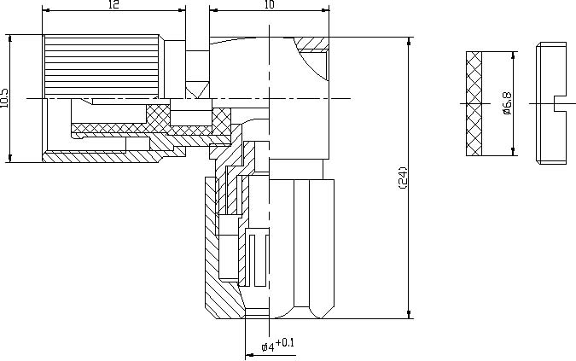

Interface
According to IEC 60169-13;CECC 22240;DIN47259
Electrical
Characteristic Impedance 75 ohm Frequency Range DC-1GHz VSWR ≤1.05@DC-100MHz
≤1.25@100-1000MHz Dielectric Withstanding Voltage ≥1000 V R.M.S,At sea level Dielectric Resistance ≥10000MΩ Peak Working Voltage 330V Contact Resistance Center Contact ≤4mΩ
Outer Contact ≤2mΩ
Mechanical
Withdrawal force inner female contact 0.5N Minimum Withdrawal force inner male contact 1.7N Minimum Insertion force between female and male 12 N Maximum Withdrawal force between female and male 22N Minimum Durability Mating cycles ≥500
Material and plating
Material Plating Body Brass Au/Ni Insulator PTFE－Center conductor Phosphor bronze Au Resilient Contact Phosphor bronze Au Coupling Nut Brass Ni Other Parts Brass Ag
Environmental
Temperature Range -40℃～+85℃ RoHs Compliant

