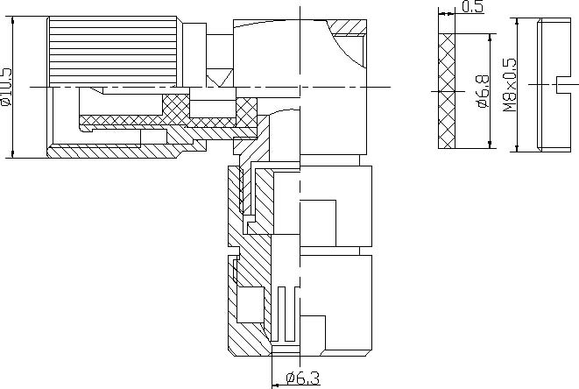
1.6/5.6 Male Right Angle Clamp Connector For RG59 Cable
Interface
According to | IEC 61169-13;CECC 22240;DIN47259
Electrical
Characteristic Impedance | 75 ohm
Frequency Range | DC-1GHz
VSWR | ≤1.25@DC-1GHz
Dielectric Withstanding Voltage | ≥1000 V R.M.S,At sea level
Dielectric Resistance | ≥10000MΩ
Contact Resistance | Center Contact ≤4mΩ
 | Outer Contact ≤2mΩ
Mechanical
Durability | Mating cycles |  | ≥500
Material and plating
 | Material | Plating
Body | Brass | Au/Ni
Insulator | PTFE | －
Center conductor | Phosphor bronze | Au
Resilient Contact | Phosphor bronze | Au
Coupling Nut | Brass | Ni
Other Parts | Brass | Ag
Gasket(O-ring) | Silicone Rubber | －
Environmental
Temperature Range | -40℃～+85℃
RoHs Compliant

