Mini UHF Male Crimp Connector For RG58 Cable

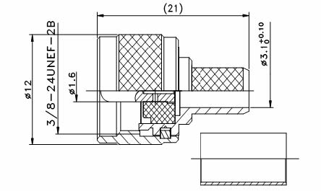

Interface
According to IEC 60169-12

Electrical
Characteristic Impedance 50ohm
Frequency Range DC-2500MHz
VSWR ≤1.20 @DC-2500MHz
Dielectric Withstanding Voltage ≥1000V RMS,50Hz,at sea level
Dielectric Resistance ≥5000MΩ
Contact Resistance Center Contact ≤5.0mΩ
Outer Contact ≤2.5mΩ

Mechanical
Durability Mating cycles ≥500

Material and plating
Material Plating
Body Brass Ni
Insulator PTFE －
Center conductor Phosphor bronze Au
Coupling Nut Brass Ni
Crimp Ferule Annealed Copper Ni
Gasket Silicone Rubber －

Environmental
Temperature Range -40℃～+85℃
Weatherproof Rate IP 67
RoHs Compliant

